Autumn 1 | Autumn 2 | Spring 1 | Spring 2 | Summer 1 | Summer 2
Reading Journey 1 | Reading Journey 1 | Reading Journey 1 | Reading Journey 1 | Reading Journey 1 | Reading Journey 1
Marvellous Me!  Fiction  (identifying key vocabulary)  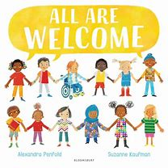  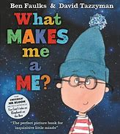  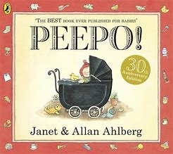  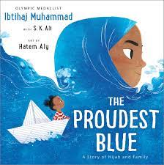  Listen to a story and comment on the events. Name the characters from a familiar story.  Talk about the stories I have heard.  Non-Fiction  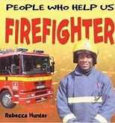  (People Who Help Us)  (National World Poetry Day  Autumn Poems)  Joins in with familiar rhymes. | Festivals and Winter Wonderland  Non- Fiction  Identifying features of a non-fiction text (Recalls facts)  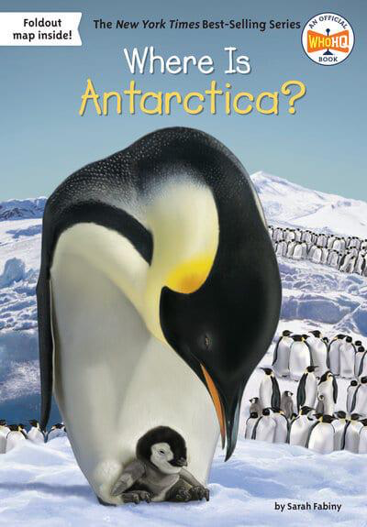  Fiction  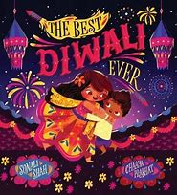  Anticipate key events in stories.  Identifies characters, setting, and key events.  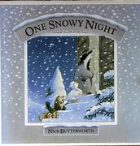  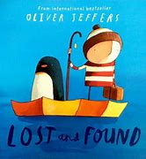  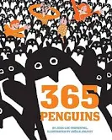  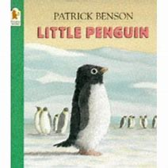  Use and understand recently introduced vocab during discussion and role-play  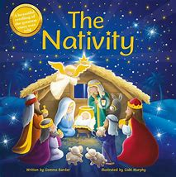 | China/Chinese New Year  Fiction  Describes key events, sequences a familiar story using images/objects.  Retells story to another person using book or images.  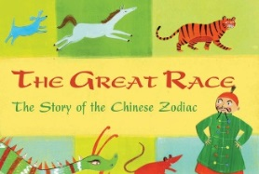  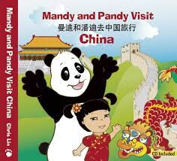  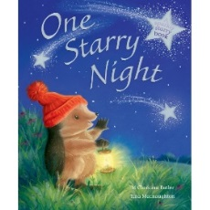  Firework Poems  Fiction  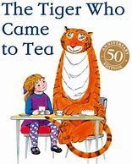  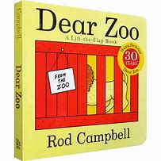  Makes predictions based on the events of a story so far.  Uses language/vocabulary from a story within role play and discussions. | Once Upon a Time…  Author Focus  Kes Gray and Jim Field  Identifying rhyming words  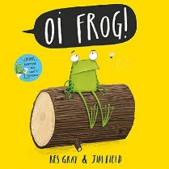  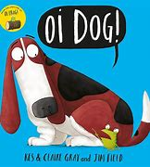  Fiction  Traditional Tales  Retelling stories and narratives using their own words and recently introduced vocabulary  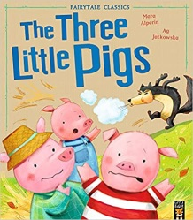  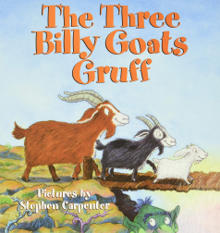  The Little Dassies-African version of The Three Little PIgs.  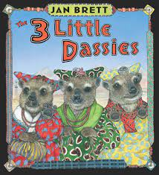  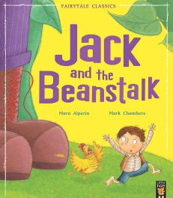  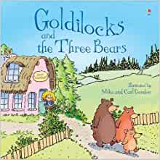  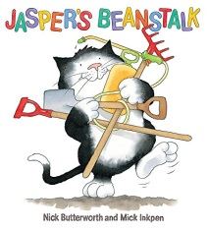  ‘Easter Poems’  ‘Mother’s Day Poems’  Nursery Rhymes |  | The Holiday Experts  Fiction  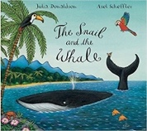  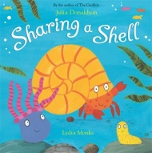  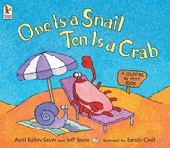  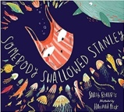  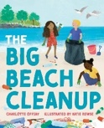  Demonstrate understanding of what has been read by retelling stories & narratives using own words and new vocabulary.  Anticipate key events in stories  Father’s Day poem  Use and understand recently introduced vocabulary during discussions about stories, non-fiction, rhymes and poems and during role play.
Long Term Overview: The Reading Journey for Reception
Non-Fiction Fiction Poetry Author focus

